Letters of Recommendation for Allyson Cerino March 6, 2013

To Whom It May Concern:

I am pleased to write a letter of recommendation for Allyson Cerino, the learning specialist at School of the Holy Child in Rye, NY. I met Allyson this past summer and have worked with her closely in a mentoring capacity. I had been the middle school learning specialist at Holy Child for seventeen years and had retired from this position in June, 2012. I was given the pleasure of advising and guiding Allyson through her first months at Holy Child.

Allyson is a warm, collegial professional who works well with students and faculty. She is knowledgeable about learning styles and is always open to learning new strategies and techniques to help the students in her care. Her written communication skills are excellent, and parents have been pleased with the attention and care she gives to their daughters. Allyson is adept at creating accommodation plans from neuropsychological testing, and she helps teachers to implement them in their classrooms. She serves as a wonderful resource for all.

It is my pleasure to recommend Allyson for a learning specialist position.

Sincerely,

Rosemary Schmelkin

rf.schmelkin@gmail.com

**Letter from a SHC Upper School Parent**

**From:** Cindy G [cindy@aol.com]  
**Sent:** Wednesday, February 27, 2013 8:44 AM  
**To:** Allyson Cerino  
**Subject:** Re: E. G-Extended Time for APs

Allyson,

...Wow! ...Thank you so very much! ....We are terribly impressed by all the actions you have taken in support of our daughter, and that you have completed all of this within an extremely tight time frame. Ellie, my husband, and I were so surprised when Ellie came home from school just a few weeks ago, telling us that you had introduced yourself, and had asked her if she would like you to see if there was anything you could do regarding approval for extended time on her AP exams. We had thought there was no longer any hope for this issue, and we also had never even met you before. Yet you volunteered to see if you could help. You immediately made phone calls, sent emails, gathered information from Ellie's teachers, and sent documentation and letters on our behalf. We are completely taken aback by your thoughtful, time-consuming hard work, and professionalism. Thank you so very, very much.

Most Sincerely,

Cindy G

-----Original Message-----  
From: Allyson Cerino <a.cerino@holychildrye.org>  
To: Cindy G <cindyG@aol.com>  
Sent: Mon, Feb 25, 2013 12:51 pm  
Subject: RE: E. G-Extended Time For APs

Hi Cindy,

The College Board’s successfully received Ellie’s testing accommodations request last week for May’s AP exams. Documentations noted below were sent to support our request. The decision process will take about 7 weeks. I will contact you as soon as I receive their decision by email; typically before a formal letter is mailed to you.

Best,

Allyson

-Dr. Lauren Riordan’s Educational Evaluation May- July 2011

-Dr. Nancy R. Spector’s Updated Letter referring to 2008 Neuropsychological Evaluation

-Teacher Survey Letters from Eleanor’s AP Calculus, AP English and AP Physics 12th grade teachers

-Past and Current Upper School Accommodation Plans

Allyson Cerino

Learning Specialist/SSD Coordinator

School of the Holy Child

2225 Westchester Avenue

Rye, NY 10580

(914) 967-5622 ext. 285

[a.cerino@holychildrye.org](https://mail.holychildrye.org/owa/redir.aspx?C=2915712d3f30463e94e8e311d38062c8&URL=mailto%3aa.cerino%40holychildrye.org)

**Letters of Recommendation**

Fieldston School

3901 Fieldston Road

Bronx, NY 10471

May 22, 2012

Dear Sirs:

I am writing on behalf of Allyson Cerino, who has applied for a position at your school. As Upper School Principal at Fieldston and as her administrative partner, I have had the pleasure of working with Allyson for the last three years in her capacity as a member of our Learning Center faculty.

Our Learning Center faculty spend most of their time working one-on-one in weekly sessions with individual students who have been identified as needing additional academic support beyond what their classroom teachers provide. For most of these students we have a psycho-educational evaluation with a diagnosed learning difference, and in addition to working one on one with a student, the Learning Center teacher works with that student’s classroom teachers to try and address the student’s particular needs. Over the past three years Allyson has worked with students in both Middle and Upper Schools at Fieldston.

One of the challenges a Learning Center teacher faces at our school is the stigma effect. Admissions at Fieldston is highly selective, and Fieldston’s visible and public academic culture emphasizes the academic strength of our student body and the rigor of our academic program. Even though we have a lot of students with diagnosed learning differences and a lot of students receiving various kinds of academic support, in such a culture many of those students who have been recommended to work with a Learning Center faculty member feel stigmatized, and in the Upper School in particular, may resist that faculty member’s help, miss appointments, beg to be “released” from Learning Center, and so on.

As Allyson’s administrative partner I recently had the opportunity directly to observe her working one-on-one with a senior boy, who I know in my role as principal to be something of a “hard case,” and I was enormously impressed to see the combination of empathy and professionalism that Allyson showed in working with that student. Although it was clear to me that he came to that session confident that Allyson was there to help him and could help him, it was still necessary for her to work through his various subjects with him so that he could reflect on where he stood in his various subjects and articulate the particular kind of help he needed. Their previous positive history and her professional and supportive outreach made their session especially productive.

The other thing noticeable in the session was how carefully Allyson had prepared for their meeting and how thoroughly up-to-date she was on this student’s current status in his classes. It can be

argued that one session a week is pretty minimal for a struggling student, but if the Learning Center teacher has taken the time to prepare for a weekly session in the way that Allyson had prepared in this case, then that weekly session can be a huge help to the student.

Allyson arrived at Fieldston in the fall of 2009 with a large repertoire of strategies that students could draw upon to meet the wide variety of academic challenges that a high school student at a school like ours is expected to meet. She has certainly added to that repertoire in the span of these last three years, but she has also grown a great deal in her ability to adapt to the variety of often hard-to-define needs that our needier students and their anxious parents present to us. I am confident that the students at your school will benefit enormously from Allyson’s work with them.

Feel free to call (718-329-7248) or email me ([jlove@ecfs.org](mailto:jlove@ecfs.org)) if you would like to discuss Allyson’s candidacy further.

Sincerely,

John Love

Upper School Principal

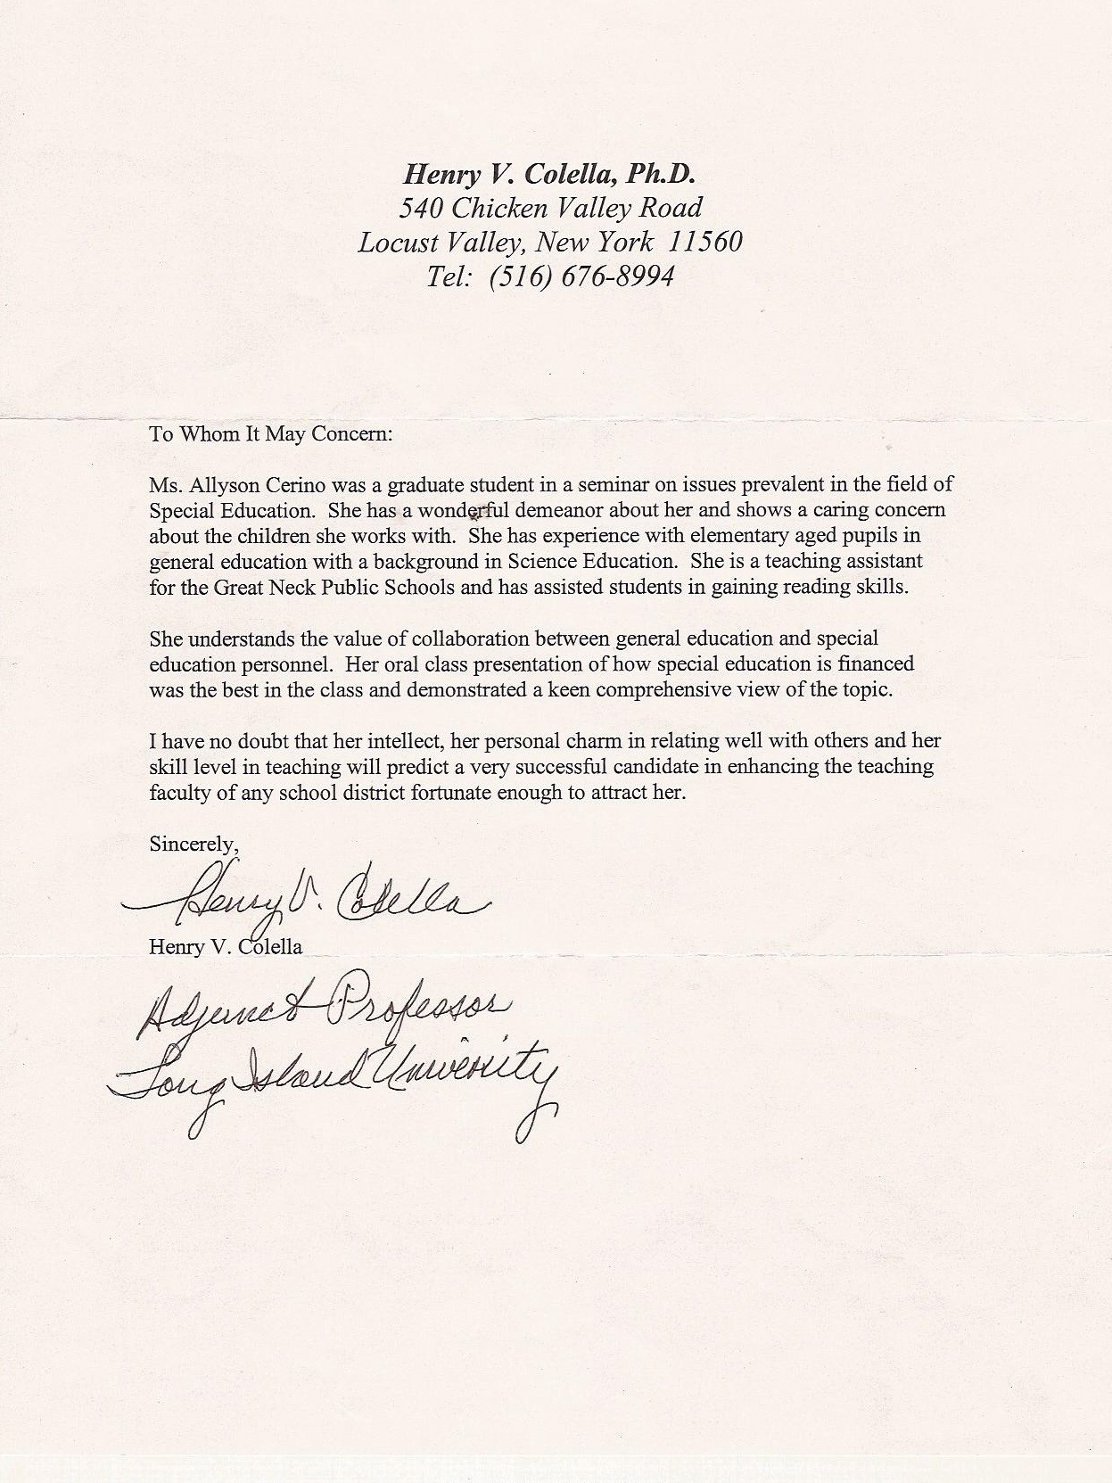

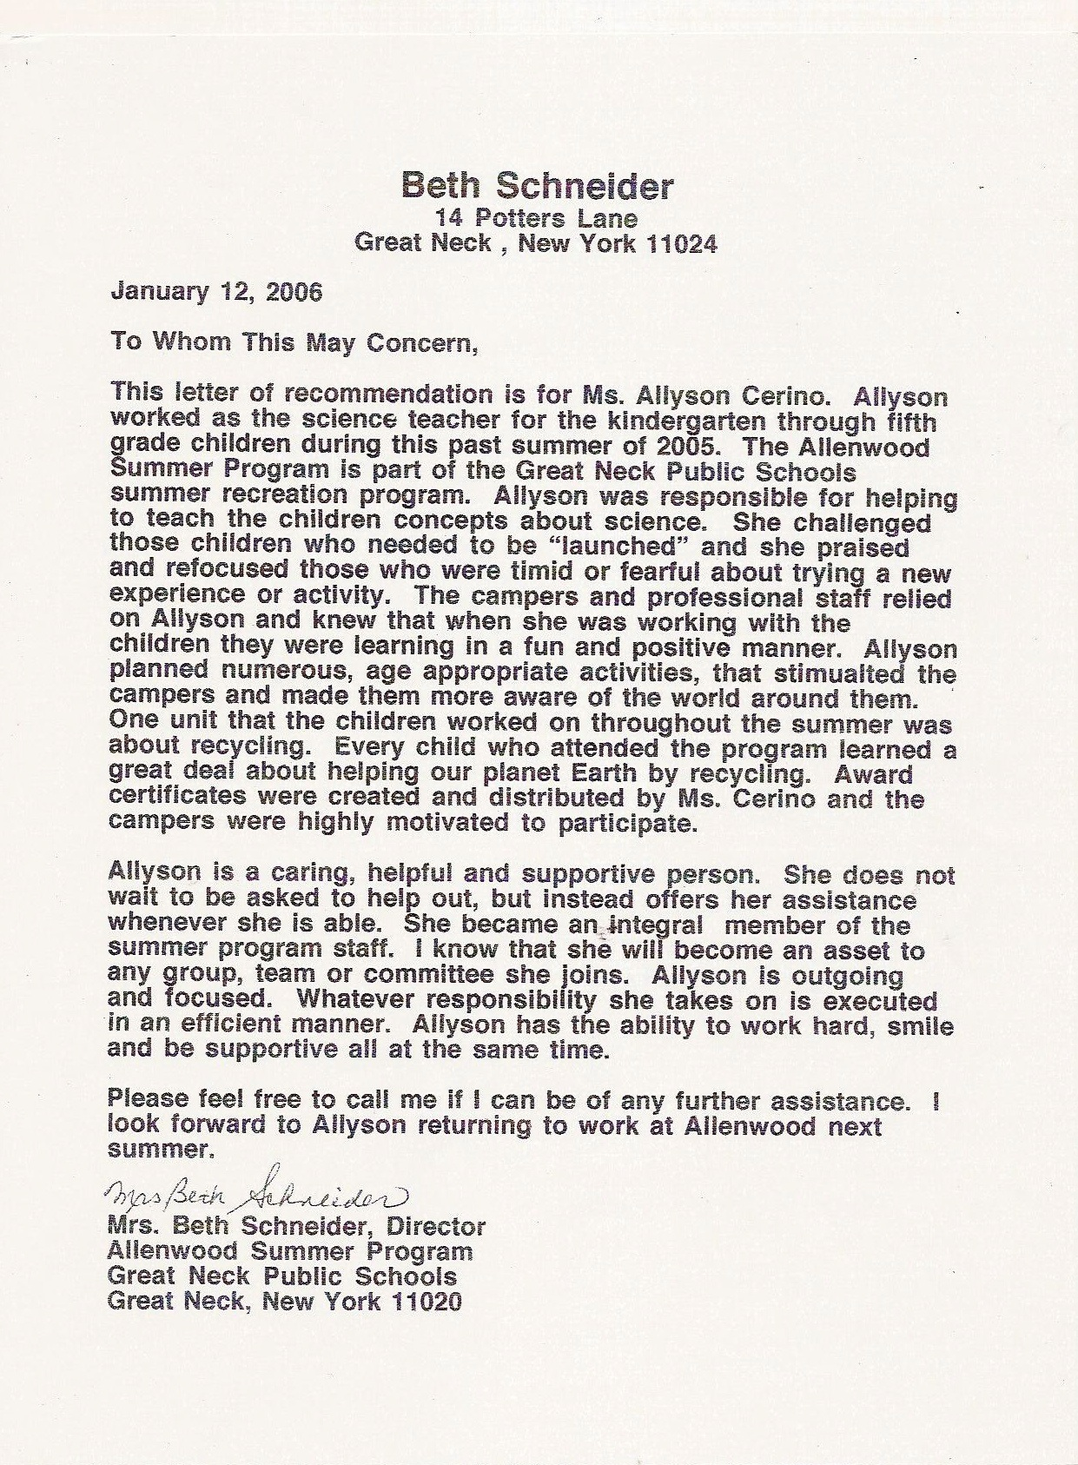

**Letter from a Fieldston Middle School Parent**

From: Joan   
Sent: Thursday, May 24, 2012 9:47 AM  
To: Cerino, Allyson  
Subject: Thank you

Dear Allyson,

I just wanted to thank you for all the work you have done with Edmund this year. Although he continues to be a “work in progress” he has made great strides in his organization skills, work habits, and his feelings about his work, thanks to the help you gave him. You observed and listened to his concerns and needs, then provided him with thoughtful strategies to address those specific needs, giving him paths, and encouragement, to being a better student. The work he has done on strategies this year helps him to know that even if there’s a glitch, he can get back on track. I also want to thank you for the way you kept all lines of communication open. I felt I always knew what was going on. You let me know if there was a way that I could help in the process, and that when there were periods of particular concern, that everyone was in the loop so that the problems could be addressed. Edmund has been very fortunate to have had an incredible team of supportive teachers and I want to thank you for the very large part you played in helping him to grow to be a more successful learner.

Many thanks again!

Joan

**Parent email—(10th grade Feildston School Student)**

**From:** Laura K  
**Sent:** Wednesday, June 09, 2010 5:05 PM  
**To:** Cerino, Allyson  
**Subject:** Re: Alex Klein- 10th Grade

On Jun 9, 2010, at 5:05 PM, Laura Klein wrote:

Dear Allyson,  
  
I can’t thank you enough for the work you have done with Alex this year.  I am sure if she shared the responses to her most recent work in English and History, she was so proud of herself.  You have really helped her feel that she can work at her writing and see results.  This is a first.  I also think Mr. Hamilton’s request for tips was such high praise for both of you.    
  
My half-joking comment to Alex was, “I hope you haven’t improved so much that you won’t get any help next year!”  She definitely still needs assistance, and obviously you and she are on the same wavelength, so it is a great match.  My question, not a joke at all, is “when can you start working with her younger brother, Hugh?”  Perhaps I will take that idea up with his advisor next year.  
  
At any rate, Alex’s first year at Fieldston is ending on a high note and I credit both her attitude and your partnership.  Many, many, many thanks.  And, have a wonderful summer.  
  
Sincerely,  
Laura  
  
 **From:** Marc K   
**Sent:** Wednesday, June 09, 2010 7:13 PM  
**To:** Cerino, Allyson  
**Subject:** Re: Alex Klein- 10th Grade

Dear Allyson,

I just want to second Laura's email. I can't tell you how much we appreciate what you have been able to accomplish with Alex this year. Best wishes

Marc

**From:** Allyson Cerino  
**Sent:** Wednesday, June 10, 2010 3:00 PM  
**To:** Marc K, Laura K  
**Subject:** Re: Alex Klein- 10th Grade (**Response to Parents)**

Dear Laura and Marc, I would like to thank you for taking the time to write those lovely notes. I am happy Alex is doing well and delighted to have been part of her successes this year. I was very impressed with her written response to Mr. Hamilton’s request—she certainly did a terrific job articulating specific strategies she found both supportive and growth promoting. She now has a set of writing skills that will stand her well for life—she should be pleased with her efforts and results! I look forward to meeting with Alex again in the fall and continuing our collaborative relationship. I wish you and your family an enjoyable and most relaxing summer!! Allyson Cerino

**US Feildston Student Email**

**From:** Alex K (**10th Grade** Student)  
**Sent:** Monday, June 07, 2010 7:09 PM  
**To:** Hamilton, Rene (**Upper School English Teacher)**  
**Cc:** Cerino, Allyson   
**Subject:** Ms. Cerino's Help

Dear Mr. Hamilton,  
You asked me on Friday to tell you how Ms. Cerino helped me with my writing. Most of her methods were aimed at helping me improve the organization of my written work.

These were some of her main tips:

1. Traditional outlines don't always work for everyone, especially me. It's okay to throw all of your ideas onto a paper, and pick out the important thoughts, and then figure out the structure.

2. For me, things tend to make more sense in my head than when I write them down. Saying what I was planning to write out loud, and then writing it down, or recording what I wanted to write and then writing it down as I listened helped address this problem.

3. Backing up arguments with evidence is extremely important. Believe it or not, I never really learned this at my old school.

4. Peer editing can be very valuable. Its okay to read your essay aloud to multiple people, and it’s good to be as open as possible to their suggestions. If things don't make sense to peers and adults, it’s not likely that they will make sense to a teacher.

5. There is nothing wrong with revisions. I used to think that editing my essay would take away from its substance, but instead I learned that edits help you focus on the key points of your writing.

I am really glad that you think that my writing has improved. I feel like over the past year, I have really worked hard on it.

  Sincerely,

Alex Klein

Past Letters of Recommendations:

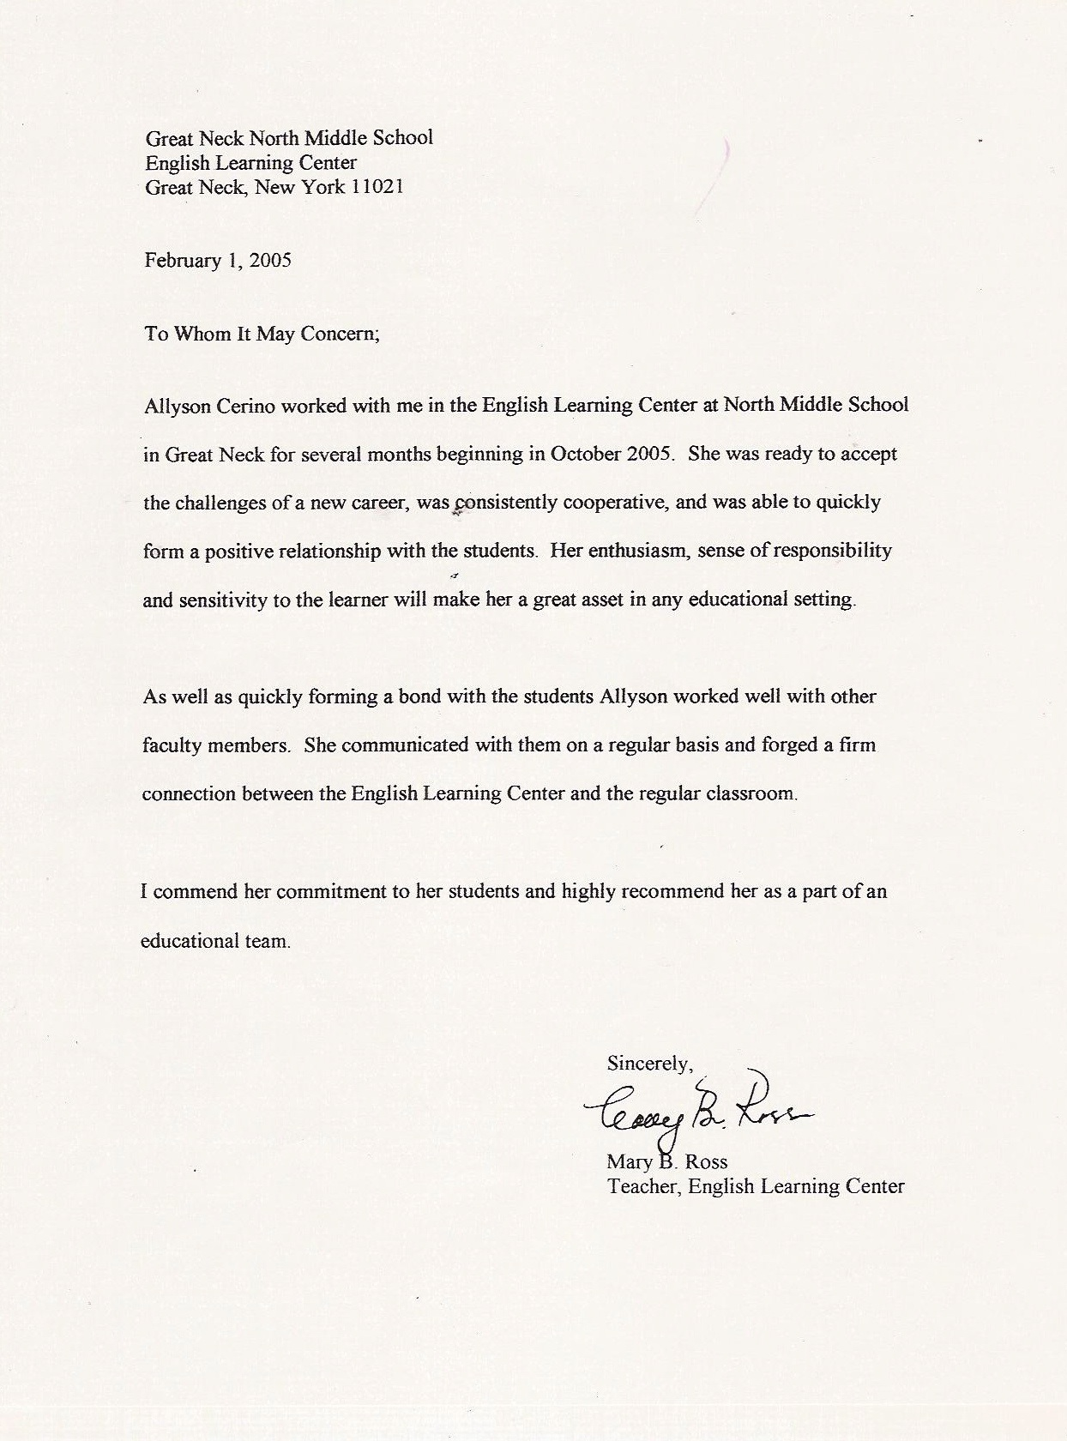

*Human Potential Unlimited, Inc.*

*Michele S. Laub, MS, president*

*52 Rochester Avenue*

*East Atlantic Beach, New Your 11561*

February 15, 2005

To whom it may concern:

This letter is a recommendation for Allyson Cerino who is presently employed by The Great Neck School District. As a friend of Allyson’s for nearly a decade, I have observed her process as she shifted from corporate and domestic design work to a private reflexology practice to embrace the profession of teaching. In teaching, Allyson has found her niche. She is excited about implementing her present University education in the classroom. She is enjoying her interaction with children; she feels fulfilled when she is able to experience the results of teaching children. She is creative and innovative in her approach. It appears that she is a talented teacher in the making.

As a retired South Middle School guidance counselor, I clearly understand the unique challenges of the Great Neck School District. Allyson has the ability to mesh with all kinds of people. Her loving, kind and inquisitive nature is apparent to all who meet her. From my point of view, empathy, creativity and a knowledge and love of subject matter are primary components of excellent teaching. Allyson possesses these characteristics as well.

I hope you will consider Allyson Cerino for positions with the Great Neck School system in the future. I am confident that she will enhance any program that she is a part of. If you wish you to contact me for more information, you may reach me at 516 897 6324

.

Yours truly,

Michele Laub